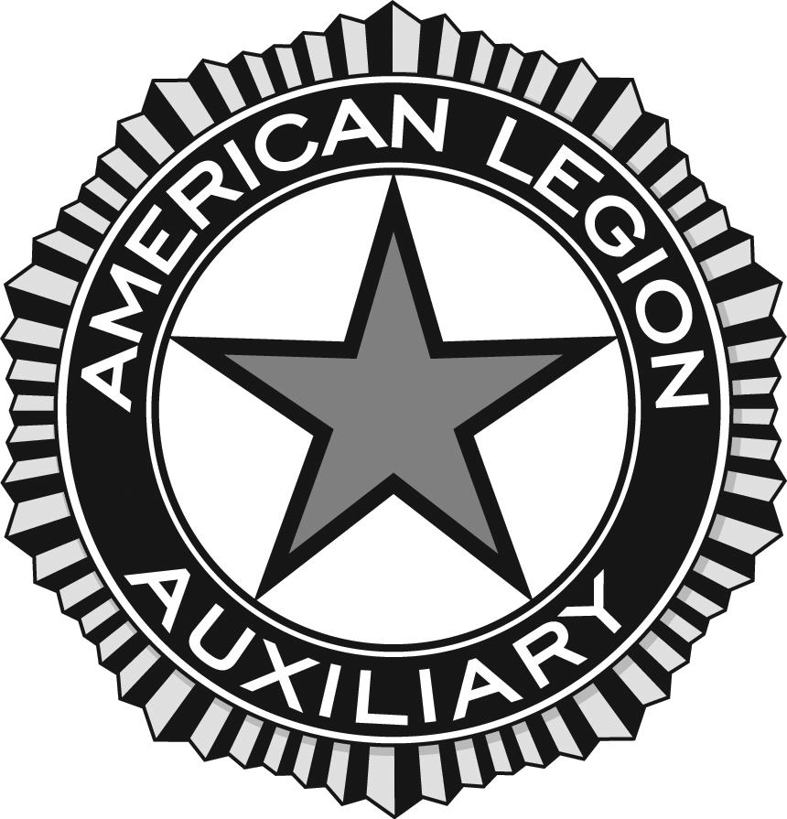

Permission to Use Photographs/videos

Subject________________________________________________________________
Location_______________________________________________________________

I grant to the American Legion Auxiliary, its representatives and employees the right to take photographs and/or video of me and my property in connection with the above-identified subject. I authorize the American Legion Auxiliary, its assigns and transferees to copyright, use and publish the same in print and/or electronically.

I agree that the American Legion Auxiliary may use such photographs/video of me with or without my name and for any lawful purpose, including, for example, such purposes as publicity, illustration, advertising, and web-related content.

I have read and understand the above:

Signature _____________________________________________________________
Printed name __________________________________________________________
Organization Name (if applicable) __________________________________________
Address ______________________________________________________________
Date _________________________________________________________________
Signature of Parent or Guardian ____________________________________________
(if under age 18)

