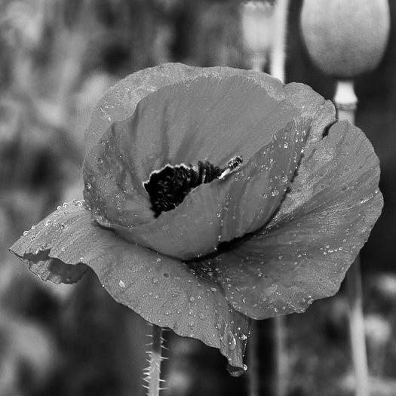

In Recognition
of
your outstanding support
of the
AMERICAN LEGION AUXILIARY
POPPY PROGRAM
On behalf of America’s veterans
Thank you,

ENTER NAME

________________________

Date

________________________

Unit President

________________________
Unit Number

